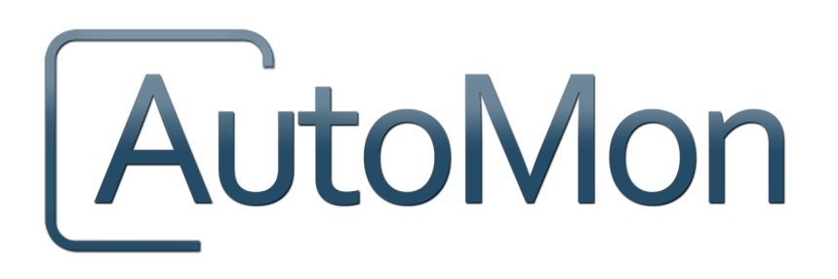
Prepared By:

AutoMon, LLC
10450 N. 74th Street, Suite 210
Scottsdale, AZ 85258
480-368-8555
www.automon.com

December 2015

Practice Manager
Version 12.0.4.1
Release Notes
Extend Your Vision
Table of Contents

Introduction 3
Software Defects 3

Introduction
Changes to Practice Manager 12.0.4.1 include corrections to software defects that were discovered in version 12.0.2.1 of Practice Manager. This document will serve to document the resolution of these software defects.

Software Defects

Note Spacing issue – When text was added to an existing note in the application, the spacing between lines of text would increase each time the note was modified, creating large sections of blank lines. This has been corrected for all Practice Manager Customers. Modifying an existing note will no longer create additional blank lines. (CRM case # 22309)

Entering hours into timeslips – When entering hours with a decimal into timeslips, the application was rounding the number. This has been corrected.

Autochanged status on workflow displayed wrong user – When a workflow item had a linked action called change matter status, it would send a pop message as the due date approach prompting the user to execute the link action. When the user did, this inadvertently showed the incorrect user in the matter history. This has now been corrected.

Forms Designer Filter error does not display fields – When a field in Forms Designer was changed and if that field was part of the filter, the user would get a pop message indicating that the query must be updated. The pop up message did not list the field that was affected. This has been resolved and will now display the field that was affected.
Document Security Flaw – In some rare cases, users were able to access to documents when the user did not have access. This has been resolved.
Change Staff information security – After the 12.0.2 upgrade, users were able to check/uncheck the Staff checkbox within the entity tab records. This has been resolved. Now when a user does not have the change staff information permission, they are not able to edit an entity’s required bar no, initials, timekeeper level or timekeeper no.
Unify login – This change only affects former Saga customers. AutoMon has removed the Saga login screens to always show the PM style login screens.
Updated help about screens – Updated the PM login splash screen from displaying 1992-2012 to 2015.
Groupware subject/body – Added the ability to customize the subject line of a groupware email. Users can now choose from any field that is available in the PM matter listing grid. Users will be able to control the order of the fields and text/separators between them.

